JUNIOR
TAG TOURNAMENT HARLOW RUGBY CLUB
(I N - HOU S E ON LY )
WHEN: SATURDAY 3rd JULY 2021
TIME: KICKS OFF 12PM (EST. FINISH @ 4PM)
RULES: 7 A SIDE, SQUAD OF 10 (or fewer), TAG RUGBY, SUBSTITUTIONS EVERY 2 MINS
MATCHES: 7 MINS EACH WAY, 2 MINS 1/2 TIME, PITCH 1 & 2
Team Name:
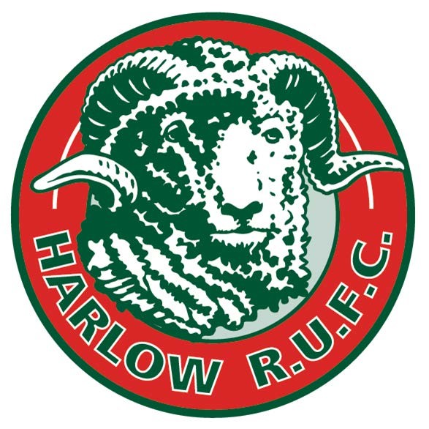
Team Colour:
Team Manager:
Team Referee:
Ages of Team Members:
Male/Female/Mixed Team:
Notes:

Please email completed form to pauloweneynon@gmail.com
before the 21st June
Please note, that each team will be required to submit a Covid-19 register before the start of play each day. (template will be provided)

